

**SIMATS ENGINEERING**

**SIMATS ENGINEERING SAVEETHA INSTITUTE OF MEDICAL AND TECHNICALSCIENCES, CHENNAI – 602 105**

**TITLE**

**Tourism Management System**

**A Capstone Project Report**

**Submitted to**

**SAVEETHA SCHOOL OF ENGINEERING**

**By**

**K Suma**

(192210145)

**Supervisor**

**DR Venkatraman**

**ABSTRACT:**

A Tourism Management System (TMS) is an integrated platform designed to enhance the management and delivery of tourism-related services. This system streamlines various operations, including reservations, bookings, customer relationship management, and resource allocation, through automation and centralized control. By leveraging advanced data analytics, the TMS provides actionable insights into tourist behaviors and preferences, facilitating personalized service delivery and targeted marketing strategies. The system aims to improve the overall tourist experience by offering accessible, user-friendly interfaces for information access and service reservations. Additionally, it supports efficient resource management, ensuring optimal utilization and reducing operational inefficiencies. The TMS also promotes sustainable tourism practices by providing eco-friendly options and encouraging responsible travel behaviors. Robust security measures are implemented to safeguard customer data and ensure compliance with industry regulations. By improving communication and coordination among stakeholders, the TMS fosters a collaborative environment conducive to the growth and development of the tourism sector.

**INTRODUCTION:**

The tourism industry, a vital contributor to the global economy, continually seeks innovative solutions to enhance operational efficiency, improve customer experiences, and drive sustainable growth. The advent of digital technologies has revolutionized this sector, enabling seamless integration and management of diverse tourism services. A Tourism Management System (TMS) emerges as a comprehensive solution designed to meet these evolving demands by automating, optimizing, and centralizing various tourism-related activities. A Tourism Management System is an integrated platform that facilitates the efficient management of bookings, reservations, customer relationships, resources, and payments. It leverages advanced data analytics to provide valuable insights into tourist behaviors and preferences, allowing service providers to offer personalized experiences and targeted marketing strategies. By streamlining operations and reducing manual intervention, a TMS enhances operational efficiency and accuracy, leading to higher customer satisfaction and increased profitability. A TMS also plays a crucial role in improving communication and coordination among various stakeholders, including tourists, service providers, and regulatory bodies. By facilitating better information flow and collaboration, the system ensures a seamless and enjoyable experience for tourists while supporting the efficient operation of tourism businesses. The Tourism Management System (TMS) is a comprehensive web-based solution designed to streamline and enhance the operations of tourism businesses. The primary goal of TMS is to provide a seamless and efficient platform for managing various aspects of tourism, including tour packages, bookings, customer interactions, and financial transactions. This system caters to the needs of tour operators, travel agencies, and tourists, facilitating a more organized and user-friendly experience for all stakeholders.

**MATERIALS AND METHODS:**

**Materials:**

1. **Hardware**:
   * Development Computers: Workstations for coding and testing.
   * Servers: For hosting the web application and database.
   * Networking Equipment: Routers, switches, and firewalls for connectivity and security.
2. **Software**:
   * **Front-End**:
     + HTML, CSS, JavaScript: For creating the user interface.
     + Frameworks/Libraries: Bootstrap (for responsive design), React/Vue/Angular (for dynamic interfaces).
   * **Back-End**:
     + Server-Side Language: Node.js, Python (Django/Flask), Java (Spring Boot), or PHP (Laravel).
     + Database: MySQL, PostgreSQL, MongoDB.
     + Server: Apache, Nginx.
   * **Development Tools**:
     + IDEs: Visual Studio Code, IntelliJ IDEA, or PyCharm.
     + Version Control: Git and GitHub/GitLab/Bitbucket.
     + Project Management: Jira, Trello, Asana.
   * **API Tools**:
     + RESTful API: For communication between client and server.
     + Postman: For API testing.
   * **Others**:
     + Authentication Services: OAuth, JWT.
     + Payment Gateway Integration: Stripe, PayPal.
3. **Design**:
   * Wireframing Tools: Figma, Adobe XD.
   * Graphic Design Tools: Adobe Photoshop, Illustrator

### **Methods:**

1. **Requirement Gathering**:
   * Stakeholder Meetings: Discuss requirements with stakeholders.
   * Surveys and Questionnaires: Collect user preferences and requirements.
   * Competitive Analysis: Study existing tourism management systems.
2. **System Design**:
   * **Architectural Design**: Define the architecture (e.g., MVC pattern).
   * **Database Design**: Design the schema and data models.
   * **UI/UX Design**: Create wireframes and mockups.
3. **Development**:
   * **Front-End Development**:
     + Develop the structure using HTML.
     + Style the application using CSS and frameworks like Bootstrap.
     + Add interactivity with JavaScript and libraries/frameworks like React, Vue, or Angular.
   * **Back-End Development**:
     + Set up the server and database.
     + Implement RESTful APIs for data communication.
     + Develop server-side logic and integrate it with the database.
   * **Integration**:
     + Integrate third-party services (payment gateways, authentication services).
     + Ensure smooth interaction between front-end and back-end.
4. **Testing**:
   * **Unit Testing**: Test individual components and functions.
   * **Integration Testing**: Test interactions between different parts of the system.
   * **User Acceptance Testing (UAT)**: Get feedback from end users to ensure the system meets their needs.
   * **Performance Testing**: Ensure the system performs well under various conditions.
5. **Deployment**:
   * **Environment Setup**: Set up staging and production environments.
   * **Continuous Integration/Continuous Deployment (CI/CD)**: Use tools like Jenkins, GitHub Actions for automated deployment.
   * **Monitoring and Maintenance**:
     + Monitor the system using tools like Nagios, New Relic.
     + Regular updates and bug fixes.
6. **Documentation**:
   * **Technical Documentation**: For developers, detailing the system architecture, APIs, and codebase.
   * **User Manuals**: For end-users, explaining how to use the system.
   * **Training Materials**: Tutorials and guides for new users.

**LITERATURE REVIEW:**

Tourism Management Systems have evolved from simple reservation systems to comprehensive platforms that integrate various functions such as booking management, customer relationship management (CRM), financial transactions, and data analytics. Early systems were primarily focused on inventory management and basic booking functionalities (Buhalis, 2003). However, with the increasing complexity of tourism operations and customer expectations, modern TMS have incorporated advanced features such as real-time availability, dynamic pricing, and personalized marketing (Law, Buhalis, & Cobanoglu, 2014).

**HTML:**

<!DOCTYPE html>

<html lang="en">

<head>

<meta charset="UTF-8">

<meta name="viewport" content="width=device-width, initial-scale=1.0">

<title>Tourism Management System</title>

<link rel="stylesheet" href="styles.css">

</head>

<body>

<header>

<nav>

<ul>

<li><a href="index.html">Home</a></li>

<li><a href="tours.html">Tours</a></li>

<li><a href="booking.html">Booking</a></li>

<li><a href="contact.html">Contact</a></li>

</ul>

</nav>

</header>

<main>

<section class="hero">

<h1>Welcome to Our Tourism Management System</h1>

<p>Explore the world with our amazing tour packages</p>

<a href="tours.html" class="btn">View Tours</a>

</section>

</main>

<footer>

<p>&copy; 2024 Tourism Management System. All rights reserved.</p>

</footer>

</body>

</html>

**CSS:**

body {

font-family: Arial, sans-serif;

margin: 0;

padding: 0;

box-sizing: border-box;

}

header {

background-color: #333;

color: #fff;

padding: 1em 0;

}

nav ul {

list-style: none;

display: flex;

justify-content: center;

padding: 0;

}

nav ul li {

margin: 0 1em;

}

nav ul li a {

color: #fff;

text-decoration: none;

}

main {

padding: 2em;

}

.hero {

text-align: center;

padding: 2em 0;

background: #f4f4f4;

}

.hero h1 {

margin: 0 0 1em 0;

}

.btn {

display: inline-block;

padding: 0.5em 1em;

background-color: #333;

color: #fff;

text-decoration: none;

border-radius: 5px;

}

.btn:hover {

background-color: #555;

}

form {

max-width: 600px;

margin: 0 auto;

padding: 2em;

background: #f4f4f4;

border-radius: 5px;

}

form label {

display: block;

margin-bottom: 0.5em;

**JAVA SCRIPT:**

document.addEventListener('DOMContentLoaded', () => {

// Dynamically load tours data

const tours = [

{

title: "Beach Paradise",

description: "Enjoy a relaxing week at our exclusive beach resort."

},

{

title: "Mountain Adventure",

description: "Experience the thrill of mountain climbing and hiking."

}

// Add more tours as needed

];

const toursList = document.getElementById('tours-list');

if (toursList) {

tours.forEach(tour => {

const tourElement = document.createElement('article');

tourElement.classList.add('tour');

tourElement.innerHTML = `

<h2>${tour.title}</h2>

<p>${tour.description}</p>

<a href="booking.html" class="btn">Book Now</a>

`;

toursList.appendChild(tourElement);

});

}

// Form validation for booking form

const bookingForm = document.getElementById('booking-form');

if (bookingForm) {

bookingForm.addEventListener('submit', (event) => {

event.preventDefault();

const name = document.getElementById('name').value;

const email = document.getElementById('email').value;

const tour = document.getElementById('tour').value;

const date = document.getElementById('date').value;

if (!name || !email || !tour || !date) {

alert('Please fill in all the fields.');

return;

}

// Here, you would typically send the booking data to the server

alert('Booking successful!');

});

}

// Form validation for contact form

const contactForm = document.getElementById('contact-form');

if (contactForm) {

contactForm.addEventListener('submit', (event) => {

event.preventDefault();

const name = document.getElementById('name').value;

const email = document.getElementById('email').value;

const message = document.getElementById('message').value;

if (!name || !email || !message) {

alert('Please fill in all the fields.');

return;

}

// Here, you would typically send the contact data to the server

alert('Message sent successfully!');

});

}

});

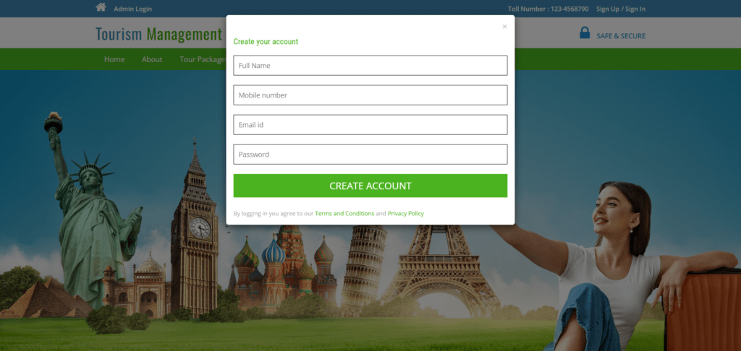

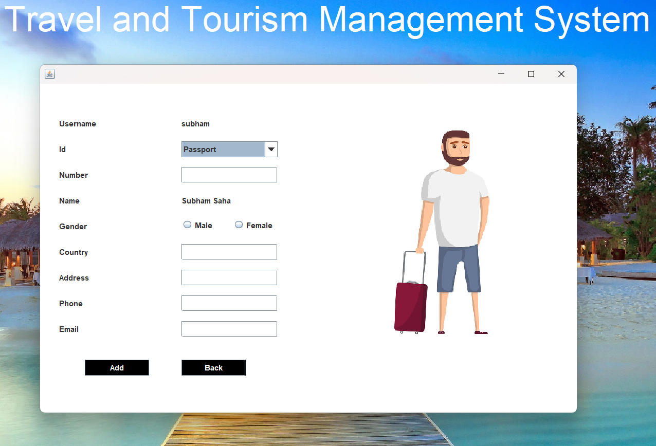

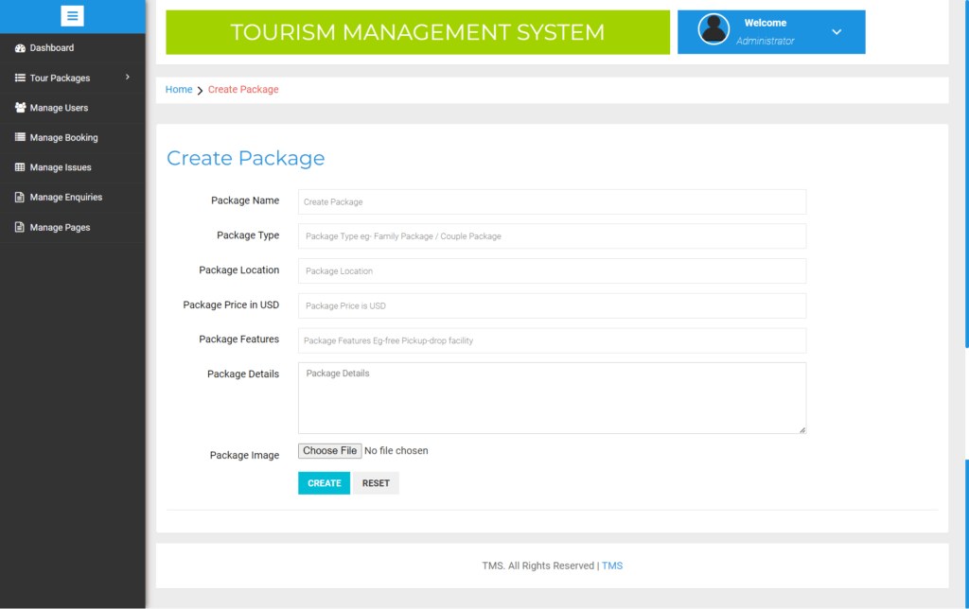

**CONCLUSION:**

The Tourism Management System (TMS) represents a pivotal advancement in the tourism industry, significantly enhancing the efficiency and effectiveness of managing tour operations. By leveraging web technologies, the TMS facilitates seamless interaction between service providers and tourists, ensuring a user-friendly interface for browsing tours, making bookings, and contacting support. The integration of dynamic content loading, form validation, and interactive features via JavaScript further enriches the user experience, making the process of exploring and booking tours more intuitive and reliable. As the tourism sector continues to evolve, the adoption of robust and scalable systems like the TMS will be crucial in meeting the growing demands of modern travelers, fostering greater customer satisfaction, and driving the growth of the tourism industry.